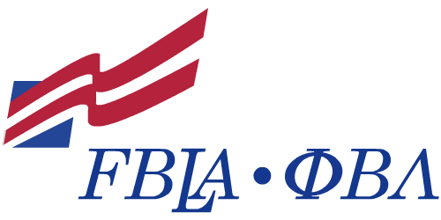
California State University, Fresno
Future Business Leaders of America- Phi Beta Lambda
(FBLA-PBL)
Membership Dues: $20.00
*Membership Break Down
National Dues per member-$10.00
State Dues per member-$10.00
Membership Form
First Name:
Last Name:
Year of Graduation:
Years in FBLA:
Years in PBL:
Gender: Male Female
Officer-ship (If Applicable):
Address:
City:
State:
Zip:
Phone Number:
Email:
I was recruited by:

—Chapter Officer/Adviser Use Only—
This member has paid dues This member has been entered online

